1. Student (snum: integer, sname: string, major: string, level: string,age: integer)  
   Class (name: string, meets at: string, room: string, d: integer)  
   Enrolled (snum: integer, cname: string)  
   Faculty (fid: integer, fname: string, deptid: integer)

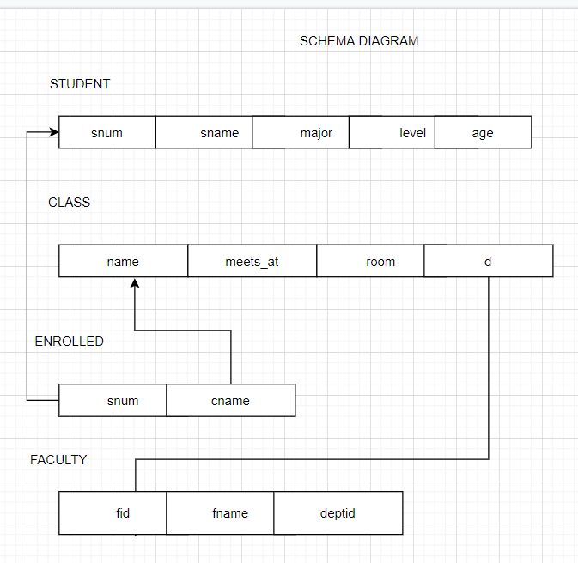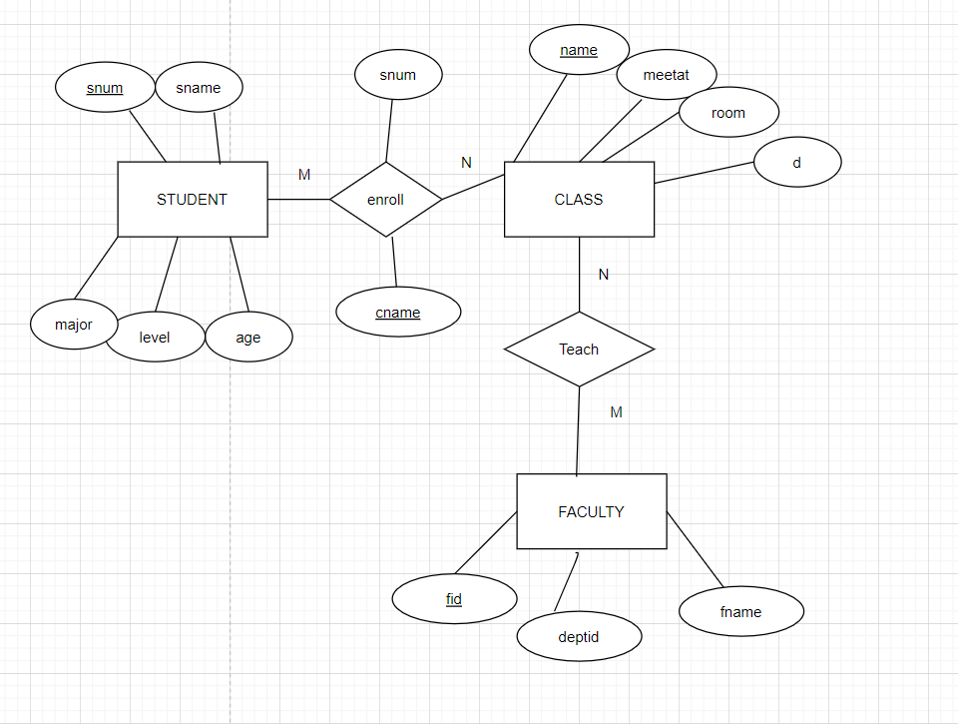

1. BRANCH(branch-name:string,branch-city:string,assets:real)  
   ACCOUNT(accno:int,branch-name:string,balance:real)  
   DEPOSITOR(customer-name:string,accno:int)  
   CUSTOMER(customer-name:string,customer-street:string,city:string)

